Section 1: Case Summary

Scenario Title: | Anaphylaxis on the Ward
Keywords: | Anaphylaxis, shock, medication error
Brief Description of Case: | This case involves the identification and initial management of anaphylaxis. The patient will become progressively more hypotensive and develop tongue swelling if not given IM epinephrine (0.3mg-0.5mg every 5mins). If given appropriate repeated epi doses, then the patients’ hemodynamics will improve and symptoms will partially resolve. Adjunctive meds (antihistamines and steroids) may be given but will not affect symptoms acutely.

Goals and Objectives
Educational Goal: | To practice the initial assessment and management of anaphylaxis
Objectives:  (Medical and CRM) | By the end of this simulation exercise, all learners will be able to:  - Recognize clinical signs/symptoms of the patient in anaphylaxis  - Demonstrate appropriate initial management of anaphylaxis  - Review the pathophysiology of anaphylaxis and initial treatment priorities  - Compare and contrast how epinephrine is packaged on the crash cart (1:10,000) vs ampule (1:1000)  - Appropriately ask for help and communicate concerns over the phone (i.e. to RACE team or attending)  - Review communication strategies in  - Disclosing medical errors to patients  - Situation development of patient’s clinical status
EPAs Assessed:

Learners, Setting and Personnel
Target Learners: | ☒ Junior Learners |  | ☐ Senior Learners |  |  | ☐ Staff
 | ☒ Physicians | ☐ Nurses |  | ☐ RTs | ☐ Inter-professional
 | ☐ Other Learners:
Location: | ☒ Sim Lab |  | ☐ In Situ |  |  | ☐ Other:
Recommended Number of Facilitators: | Instructors: 1
 | Sim Actors: 1
 | Sim Techs: 1

Scenario Development
Date of Development: | 2015
Scenario Developer(s): | Dr. Tim Chaplin
Affiliations/Institutions(s): | Queen’s University
Contact E-mail: | chaplintim2@gmail.com
Last Revision Date: | Jan 2020
Revised By: | Dr. Chris Heyd
Version Number: | 1

Section 2A: Initial Patient Information

- Patient Chart
Patient Name: Keith Anderson |  |  |  | Age: 68 | Gender: M | Weight: 80kg
Presenting complaint: Rash
Temp: 36.5 ºC | HR: 122 | BP: 86/40 |  | RR: 18 | O₂Sat: 96% | FiO₂: Room air
Cap glucose: 5.6 |  |  |  | GCS: 15
Triage note:
It’s 9:00 pm and you have been called to assess a patient who has developed a rash and nausea shortly after starting an IV dose of pip/tazo. On handover you were told the patient was a 68M who was admitted this morning for treatment of a diabetic foot infection that has been progressing despite oral antibiotics.

Allergies: Penicillin (Unknown reaction)
Past Medical History:  Type 2 diabetes |  |  | Current Medications:  Metformin PO 1g BID  Sitagliptin PO 100mg daily  Canagliflozin PO 200mg daily

Section 2B: Extra Patient Information

A. Further History
Include any relevant history not included in triage note above. What information will only be given to learners if they ask? Who will provide this information (mannequin’s voice, sim actors, SP, etc.)?

RN to provide when asked: You’ve taken care of Mr. Anderson since the beginning of your shift 2 hours ago. He is a very pleasant gentleman admitted for a severe diabetic foot infection who developed a whole body rash, throat itchiness, and nausea about 5 minutes after you started a pip/taz infusion. You call the resident for help immediately.
IF asked, you can consult the patient’s chart and determine that he is only on piperacillin-tazobactam, metformin and oral morphine prn. He is full code. He is allergic to penicillin (this was apparently unknown to the admitting team during the day – they wrote the orders for the pip-taz)

B. Physical Exam
List any pertinent positive and negative findings
Cardio: Nil | Neuro: Nil
Resp: Diffuse wheeze | Head & Neck: Nil
Abdo: Soft, non-tender | MSK/skin: Diffuse urticarial rash on trunk and arms
Other: No visible oral swelling

Section 3: Technical Requirements/Room Vision

A. Patient
☒ Mannequin Adult
☐ Standardized Patient
☐ Task Trainer
☐ Hybrid
B. Special Equipment Required
None

C. Required Medications
Cardiac epinephrine
Epinephrine ampule
Epi-pen
Ventolin

D. Moulage
Hospital gown
Diffuse urticaria rash
20G IV with medication infusing

E. Monitors at Case Onset
☐ Patient on monitor with vitals displayed
☒ Patient not yet on monitor
F. Patient Reactions and Exam
Include any relevant physical exam findings that require mannequin programming or cues from patient
(e.g. – abnormal breath sounds, moaning when RUQ palpated, etc.) May be helpful to frame in ABCDE format.

Diffuse wheeze bilaterally

Section 4: Sim Actor and Standardized Patients

Sim Actor and Standardized Patient Roles and Scripts
Role | Description of role, expected behavior, and key moments to intervene/prompt learners. Include any script required (including conveying patient information if patient is unable)
Bedside RN | RN NOTES:  - You’ve taken care of Mr. Anderson since the beginning of your shift 2 hours ago. He is a very pleasant gentleman admitted for a severe diabetic foot infection who developed a whole body rash, throat itchiness, and nausea about 5 minutes after you started a pip/taz infusion. You call the resident for help immediately.  - IF asked, you can consult the patient’s chart and determine that he is only on piperacillin-tazobactam, metformin and oral morphine prn. He is full code. He is allergic to penicillin (this was apparently unknown to the admitting team during the day – they wrote the orders for the pip-taz)

Section 5: Scenario Progression

Scenario States, Modifiers and Triggers
Patient State/Vitals | Patient Status | Learner Actions, Modifiers & Triggers to Move to Next State |  | Facilitator Notes
1. Baseline State  Rhythm: Sinus tach  HR: 122  BP: 86/40  RR: 18  O₂SAT: 96%  T: 36.5ºC  GCS: 15 | Pt: “I’m feeling a bit short of breath and light headed” | Expected Learner Actions  Monitors  Focused history and physical  Place patient on oxygen  Stop antibiotic infusion  Order IM epinephrine (0.3-0.5mg)  Call for help | Modifiers  Triggers  For progression to next state  - No Epi or ongoing infusion at 3 min → 2. Worsening  - All actions complete → 3. Improving
2. Worsening  Rhythm: Sinus tach  HR: 140  BP: 75/35  RR: 24  O₂SAT: 96% | RN: “It looks like his lips are starting to swell. Do you think it could be the antibiotic?” | Expected Learner Actions  Stop antibiotic infusion  Give IM epinephrine 0.3-0.5mg | Modifiers  - If no epi IM given, RN to prompt  Triggers  - All actions complete → 3. Improving
3. Improving  Rhythm: Sinus tach  HR: 122  BP: 100/40  RR: 18  O₂SAT: 96% | Pt “I am feeling a little better but my throat is still itchy.”  Normal lips and oropharynx on examination | Expected Learner Actions  Reassess patient  Ventolin MDI  Steroid IV (e.g. methylprednisolone, dexamethasone, hydrocortisone)  Antihistamine IV or PO  Bolus of 1L normal saline  Consider 2nd dose IM Epi | Modifiers  Triggers  -All actions complete → 4. Stabilization
4. Stabilization  Rhythm: Sinus tach  HR: 110  BP: 110/65  RR: 18  O₂SAT: 99% |  | Expected Learner Actions  Discuss med error with patient  Discuss disposition with RACE/Senior resident | Modifiers  Triggers  - All actions complete → END CASE

Appendix A: Laboratory Results (admission bloodwork)

CBC
WBC 14
Hgb 130
Plt 220

Lytes
Na 137
K 3.8
Cl 97
HCO₃ 24
Urea 7.4
Cr 137

Appendix B: ECGs, X-rays, Ultrasounds and Pictures

No imaging given in this case

Appendix C: Facilitator Cheat Sheet & Debriefing Tips

Include key errors to watch for and common challenges with the case. List issues expected to be part of the debriefing discussion. Supplemental information regarding any relevant pathophysiology, guidelines, or management information that may be reviewed during debriefing should be provided for facilitators to have as a reference.

1. Clear communication (with RN, staff on the phone, patient) and management priorities (SBAR)

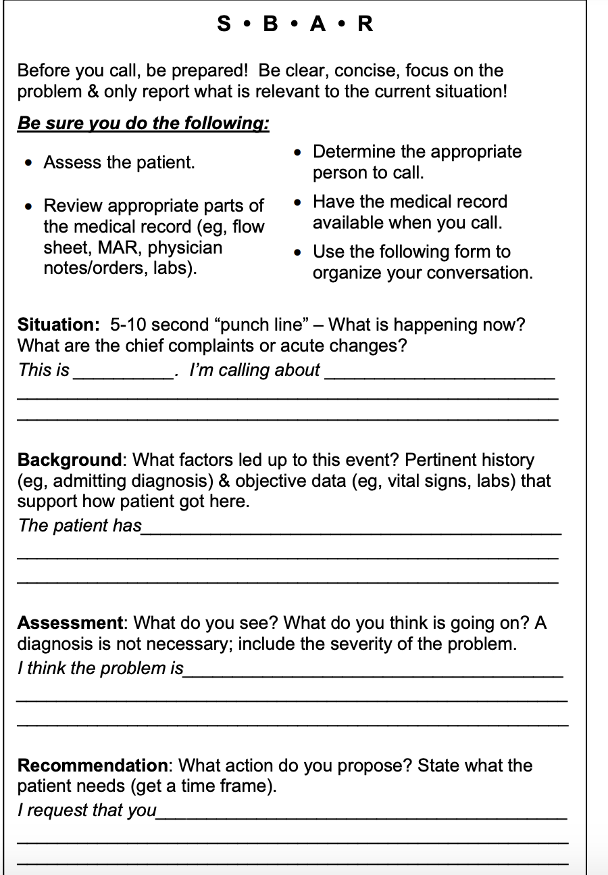

2. Discuss the initial approach to the patient with anaphylaxis and its management algorithm

3.Understand available epinephrine concentration and doses (ie crash cart 1:10,000 vs ampule 1:1000)

4. Definition of anaphylaxis
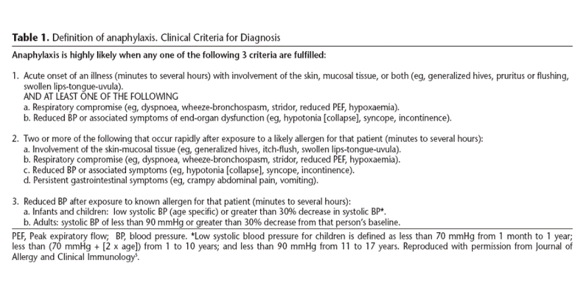
5. Communication method on breaking medication error
- Begin by stating there has been an error;
- Describe the course of events, using nontechnical language;
- State the nature of the mistake, consequences, and corrective action;
- Express personal regret and apologize;
- Elicit questions or concerns and address them; and
- Plan the next step and next contact with the patient.

References

1. https://en.wikipedia.org/wiki/SBAR
2. https://www.ncbi.nlm.nih.gov/pmc/articles/PMC6838992/
3.

